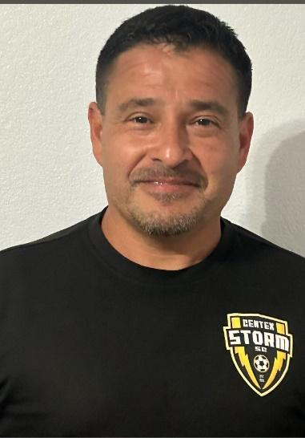
Frank (Ponch) Diaz
Soccer Coach/Trainer
Centex Storm SC
aztecfutsalandtraining@gmail.com
(254) 231-2909

PROFILE
Soccer coach with 30 years+ of coaching experience, 24 years with Centex Storm SC. Soccer Coach/Trainer with foundation experience in guiding athletes and supporting team success. Dedicated and empathetic coach/trainer working with players of all ages. Skilled in coaching techniques, soccer analytics, and fostering team collaboration. Strong commitment to sportsmanship and effective communication, apply organizational skills and strategic insights to advance coaching methodologies and athlete development. Proven ability to motivate and develop players, while also fostering a positive team environment.
EDUCATION
National D License
National F License
11v11 Blended Grassroots
7v7 Blended Grassroots
4v4 Blended Grassroots
Introduction to Grassroots
Regional Diploma
State Diploma
11v11 Pre-National Diploma
Goalkeeping Level 1
Sports Psychology and Individual Mental Skills
The Role of the Sporting Director-Soccer
11v11 Formations & Systems of Play Diploma
Attacking Transitions and Counter Attacking Diploma
Attacking Transitions Principles and Habits That Shape Our Identity Certificate
Functional Training For Forwards Certificate
Creating Goal Scoring Opportunities’ Certificate
How To Train for the Physical Demands Of Counter Attacking and Counter Pressing Certificate
Technique: 2 Player Passing Exercises
Technique: 2 player and 3 Player Passing Exercises
Futsal Level 1 Diploma
Futsal Goalkeeper Analysis and Training

